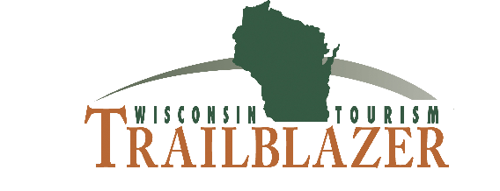
2021 ENTRY FORM
Entry Deadline: Friday, October 8, 2021

Name |  | Contact Name |  | Contact Title | Title
Contact Phone |  | Phone |  | Contact email address | Email
Submitting Organization |  | Submitting Organization
Address |  | Address
City |  | City |  | State | State | Zip | Zip
Select ONE of the six categories from dropdown: Choose ONE of the six categories:
Project Name |  | Project Name
Measurable Project Goals |  |  | Tactics |  |  | Goal Metric | End Metric
1 | Measurable Project Goal |  | Tactic |  |  | Goal Metric | End Metric
2 | Measurable Project Goal |  | Tactic |  |  | Goal Metric | End Metric
3 | Measurable Project Goal |  | Tactic |  |  | Goal Metric | End Metric
4 | Measurable Project Goal |  | Tactic |  |  | Goal Metric | End Metric
5 | Measurable Project Goal |  | Tactic |  |  | Goal Metric | End Metric

Eligibility:
- Open to all Wisconsin tourism-related businesses and organizations.
- Entries completed and submitted by marketing agencies must be submitted in the name of the client.
- All entries must have been executed between October 1, 2020, and September 30, 2021.
- No limit on the number of entries per organization.
- When applicable, entries should include original support materials.

Judging criteria:
The Destinations Wisconsin Education Committee will judge entries based on whether they meet the projects’ objectives as well as exhibit creativity, quality and effectiveness. Entry form must be complete for the entry to be considered.

Questions should be directed to Julia Hertel at 608.837.6693 or jhertel@destinationswisconsin.com. Deadline for entries is October 8, 2021.

Mailing address for hard copy samples:
Destinations Wisconsin
2480 Monaghan Way
PO Box 393
Sun Prairie, WI 53590

